1. 測試內容：

測試L2 Group Entry with type “SELECT”能否正確安裝。

1. 測試環境架構：

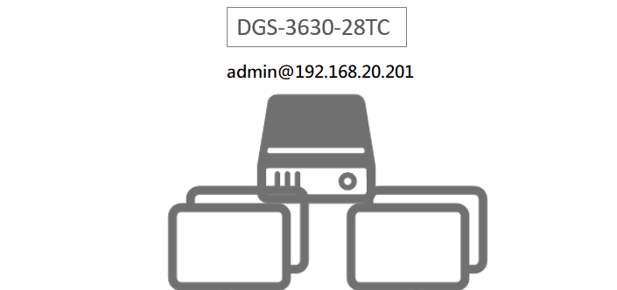

1. 測試環境組態：

* SDN controller: ONOS 1.15.1
* Switch: DGS-3630
* Apps:

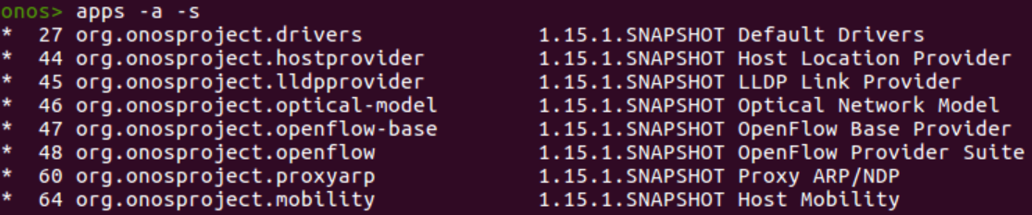

1. 使用之JSON文件：
   * 根據*Appendix - OpenFlow Object Details.pdf*，建立SELECT group需要使用下列五項group entries：

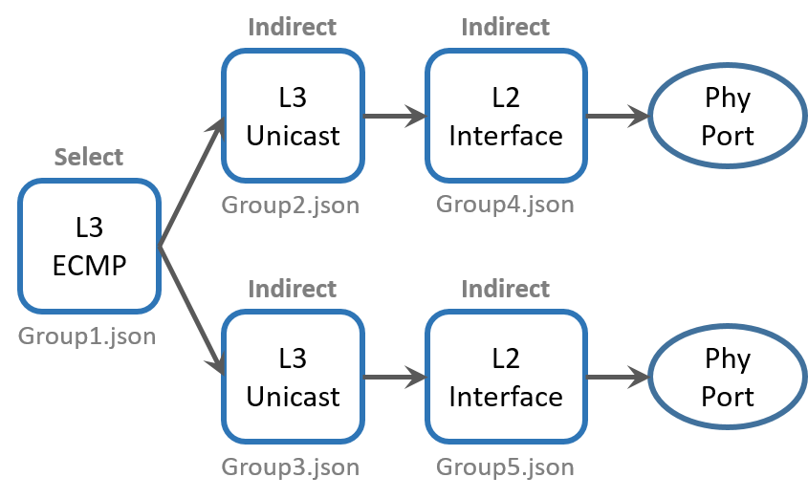

* + 此外，L3 Unicast的部分也依據規格書的內容，額外加上Decrement TTL以及Set-Fields。

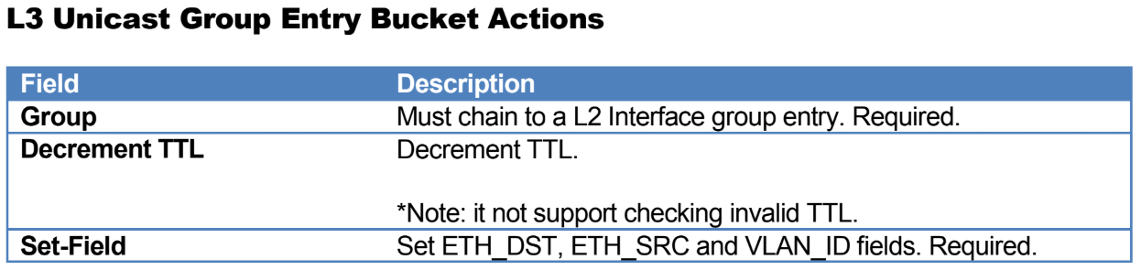

* + L2 interface 1 (group4.json)

|  |
| --- |
| {  "type":"INDIRECT",  "appCookie":"0x10001",  "groupId":"65537",  "buckets":[  {  "treatment":{  "instructions":[  {  "type":"OUTPUT",  "port":"1"  }  ]  }  }  ]  } |

* + L2 interface 2 (group5.json)

|  |
| --- |
| {  "type":"INDIRECT",  "appCookie":"0x10002",  "groupId":"65538",  "buckets":[  {  "treatment":{  "instructions":[  {  "type":"OUTPUT",  "port":"2"  }  ]  }  }  ]  } |

* + L3 Unicast 1 (group2.json)

|  |
| --- |
| {  "type":"INDIRECT",  "appCookie":"0x20000001",  "groupId":"536870913",  "buckets":[  {  "treatment":{  "instructions":[  {  "type":"GROUP",  "groupId":"65537"  },  {  "type":"L2MODIFICATION",  "subtype":"VLAN_ID",  "vlanId":1  },  {  "type":"L2MODIFICATION",  "subtype":"ETH_SRC",  "mac":"00:00:00:11:22:33"  },  {  "type":"L2MODIFICATION",  "subtype":"ETH_DST",  "mac":"00:00:00:01:02:03"  },  {  "type":"L3MODIFICATION",  "subtype":"DEC_TTL"  }  ]  }  }  ]  } |

* + L3 Unicast 2 (group3.json)

|  |
| --- |
| {  "type":"INDIRECT",  "appCookie":"0x20000002",  "groupId":"536870914",  "buckets":[  {  "treatment":{  "instructions":[  {  "type":"GROUP",  "groupId":"65538"  },  {  "type":"L2MODIFICATION",  "subtype":"VLAN_ID",  "vlanId":1  },  {  "type":"L2MODIFICATION",  "subtype":"ETH_SRC",  "mac":"00:00:00:11:22:33"  },  {  "type":"L2MODIFICATION",  "subtype":"ETH_DST",  "mac":"00:00:00:01:02:03"  },  {  "type":"L3MODIFICATION",  "subtype":"DEC_TTL"  }  ]  }  }  ]  } |

* + L3 ECMP (group1.json)

|  |
| --- |
| {  "type":"SELECT",  "appCookie":"0x70000001",  "groupId":"1879048193",  "buckets":[  {  "treatment":{  "instructions":[  {  "type":"GROUP",  "groupId":"536870913"  }  ]  },  "weight":"1"  },  {  "treatment":{  "instructions":[  {  "type":"GROUP",  "groupId":"536870914"  }  ]  },  "weight":"1"  }  ]  } |

* + Flow rule (flow.json)

|  |
| --- |
| {  "flows":[  {  "priority":40001,  "timeout":0,  "isPermanent":true,  "deviceId":"of:000078321bdf7600",  "selector":{  "criteria":[  {  "type":"IN_PORT",  "port":1  },  {  "type":"ETH_TYPE",  "ethType":"0x0800"  },  {  "type":"IPV4_DST",  "ip":"192.168.202.2/24"  }  ]  },  "treatment":{  "instructions": [],  "deferred": [  {  "type":"GROUP",  "groupId":"1879048193"  }  ]  }  }  ]  } |

1. 測試步驟：

* 使用以下指令倒序安裝group rules：

|  |
| --- |
| for i in {5..1}; do curl –user onos:rocks –X POST –H “Content-type: application/json” -d @group$i.json http://localhost:8181/onos/v1/groups/of:000078321bdf7600; done |

* 再安裝flow rule：

|  |
| --- |
| curl --user onos:rocks -X POST -H "Content-type: application/json" -d @flow.json http://localhost:8181/onos/v1/flows |

* 查看ONOS GUI Group view

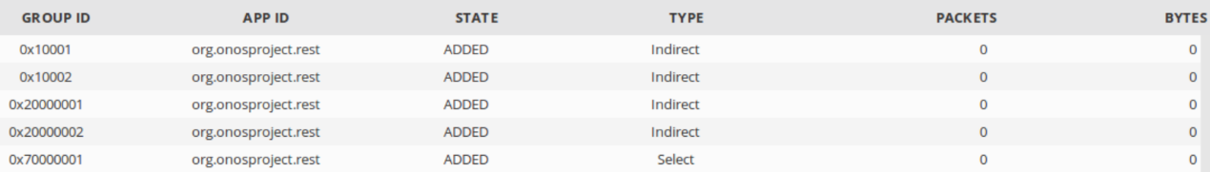

* 透過switch CLI查看groups

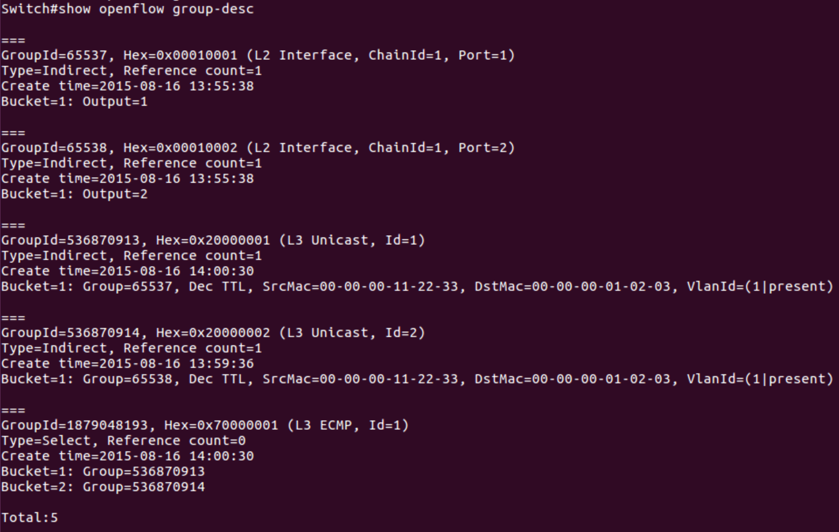

可以發現五條group entries都成功安裝。

* 查看ONOS GUI Flow view

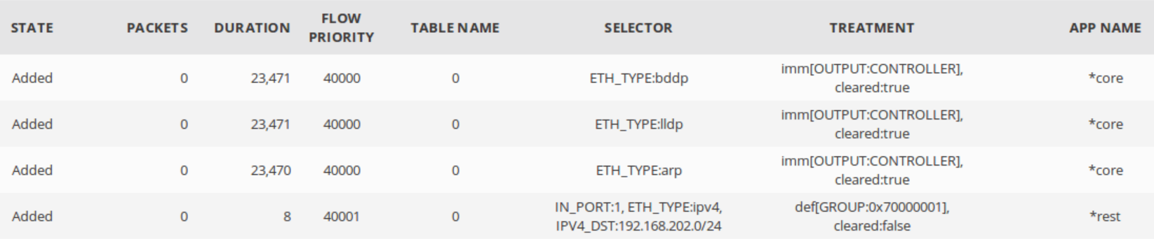

* 透過switch CLI查看flows (僅擷取後三條)

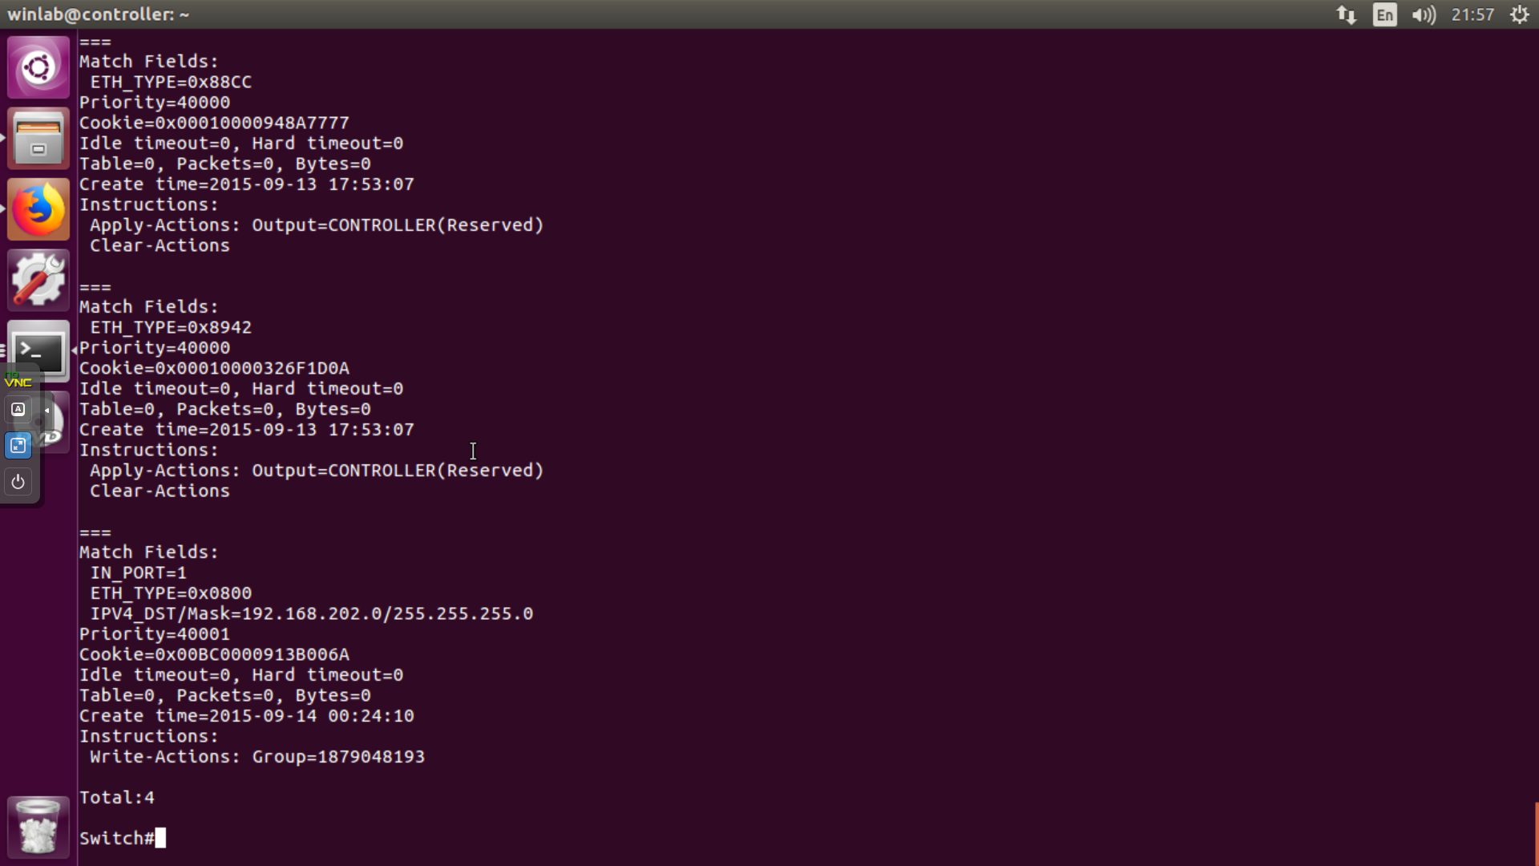

可以發現指向SELECT group的flow rule也順利安裝。

* test1
* ping 192.168.205.2

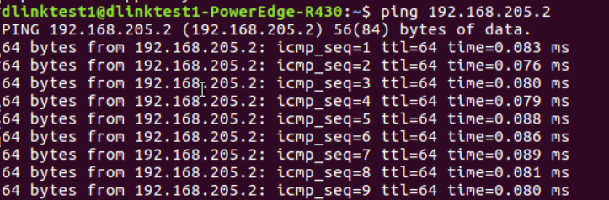

* test2
* sudo tcpdump -nni enp4s0 ip

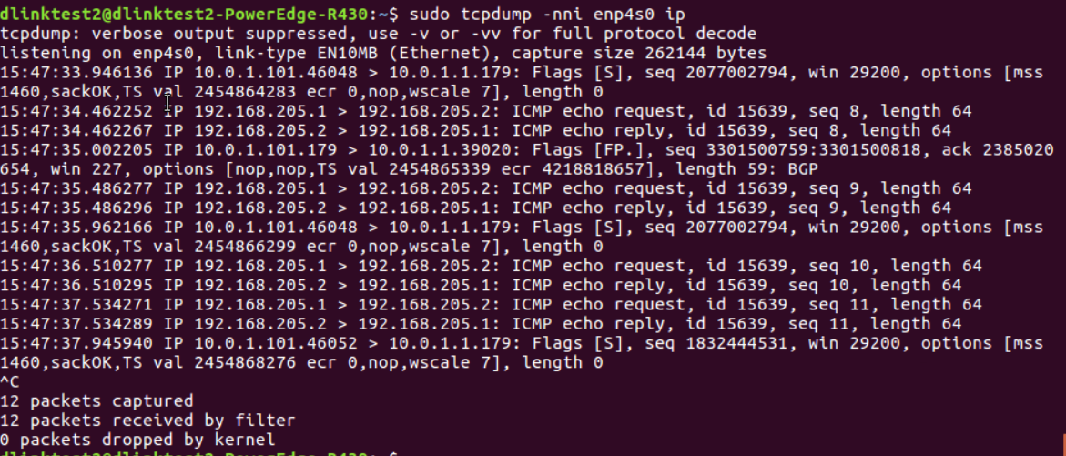

1. 測試結果：

L2 Group Entry with type “SELECT”能夠正確安裝。